

Year 9 Science 2018
Chemistry 1 Test: Atoms and equations

SECTION 1: MULTIPLE CHOICE (15 Questions: 15 marks for this section)
Circle your answer on the multiple choice answer sheet.

- A substance takes the shape of the bottom of its container and is able to be poured from one container to another without any change in volume. The substance is
  - a solid.
  - a liquid.
  - a gas.
  - plasma.

- The Kinetic Theory describes how particles behave when they are heated. Which of the following statements is incorrect, according to the Kinetic Theory?
  - particles move in straight lines until they collide with another particle or the wall of their container.
  - particles move slower when they are heated.
  - particles are close together in solids.
  - when particles have enough heat energy they can break the bonds that hold them together.

- Which type of particles is not found in the nucleus of an atom?
  - protons
  - neutrons
  - electrons
  - quarks

- Which of the statements below is incorrect about protons?
  - Protons are positively charged.
  - Protons have a relative mass of 1.
  - The number of protons in an atom determines which element it is.
  - Protons are much smaller than electrons.

- What is the formula of sodium?
  - S
  - So
  - Na
  - Sm

- K is the element symbol for
  - Krypton.
  - Copper.
  - Phosphorus.
  - Potassium

- A substance that contains more than one type of atoms, chemically combined is called
a) an element.
b) a compound.
c) a molecule.
d) a mixture.

- CO₂ is the formula for
  - cobalt.
  - carbon monoxide.
  - carbon oxide.
  - carbon dioxide.

- What atoms are in one molecule of water?
  - Water atoms.
  - One hydrogen and two oxygen atoms.
  - Two hydrogen and one oxygen atoms.
  - Two hydrogen and two oxygen atoms.

- NaCl is the symbol for the compound that is commonly known as
  - air.
  - water.
  - salt.
  - Bicarbonate of soda.

- When sterilising dressings you would use?
  - Gamma radiation
  - Alpha radiation
  - Beta radiation
  - Electrons

- If an atom has 11 protons and 12 neutrons then the number of electrons around the nucleus is:
  - 2
  - 12
  - 11
  - 23

- If the half-life of carbon-14 is 5600 years, about what percentage of the original radioactive carbon-14 would you expect to find in a human bone 17000 years old?
  - 50%
  - 25%
  - 70%
  - 12.5%

The diagram below represents the ability for the different types of radiation to pass through different materials. Refer to this diagram to answer questions 14 and 15.

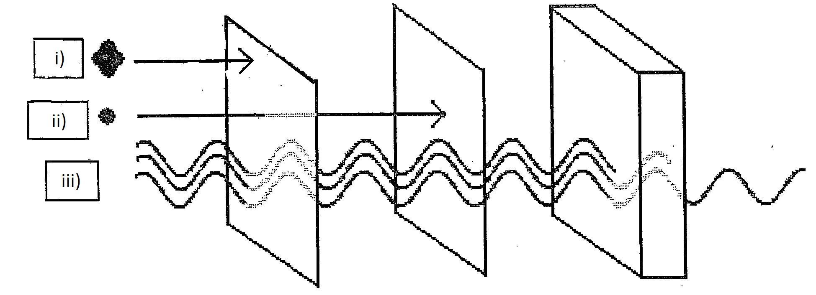
Paper Aluminium Lead

- The type of radiation represented by ii) is:
  - X-ray
  - Beta
  - Gamma
  - Alpha

- The following statement is correct for iii):
  - Has a high positive charge
  - Moves at high speeds and has a negative charge
  - Has high energy and can travel for kilometres through air
  - Not considered dangerous to humans

SECTION 2: WRITTEN (7 questions: 22 marks for this section)
Write your answers on the lined paper provided.

- Explain what happens to the particles and bonds in a piece of ice when it is heated until it melts. (1 mark)

- Explain the difference between nuclear fission and fusion. (4 marks)

- Write the symbols for the following elements: (7 marks)
- Aluminium
- Gold
- Nitrogen
- Neon
- Helium
- Uranium
- Iron

- Use your periodic table to find the following information: (4 marks)
- What is the atomic number of oxygen?
- What is the relative atomic mass of aluminium?
- How many protons are there in an atom of sulfur?
- How many elements are found in the first period (row)?

- Carbon-12 and carbon-14 are two isotopes of carbon. Explain what the term isotope means? (1 mark)

There is another question on the next page

- Use the diagram below to answer the following questions relating to nuclear power stations
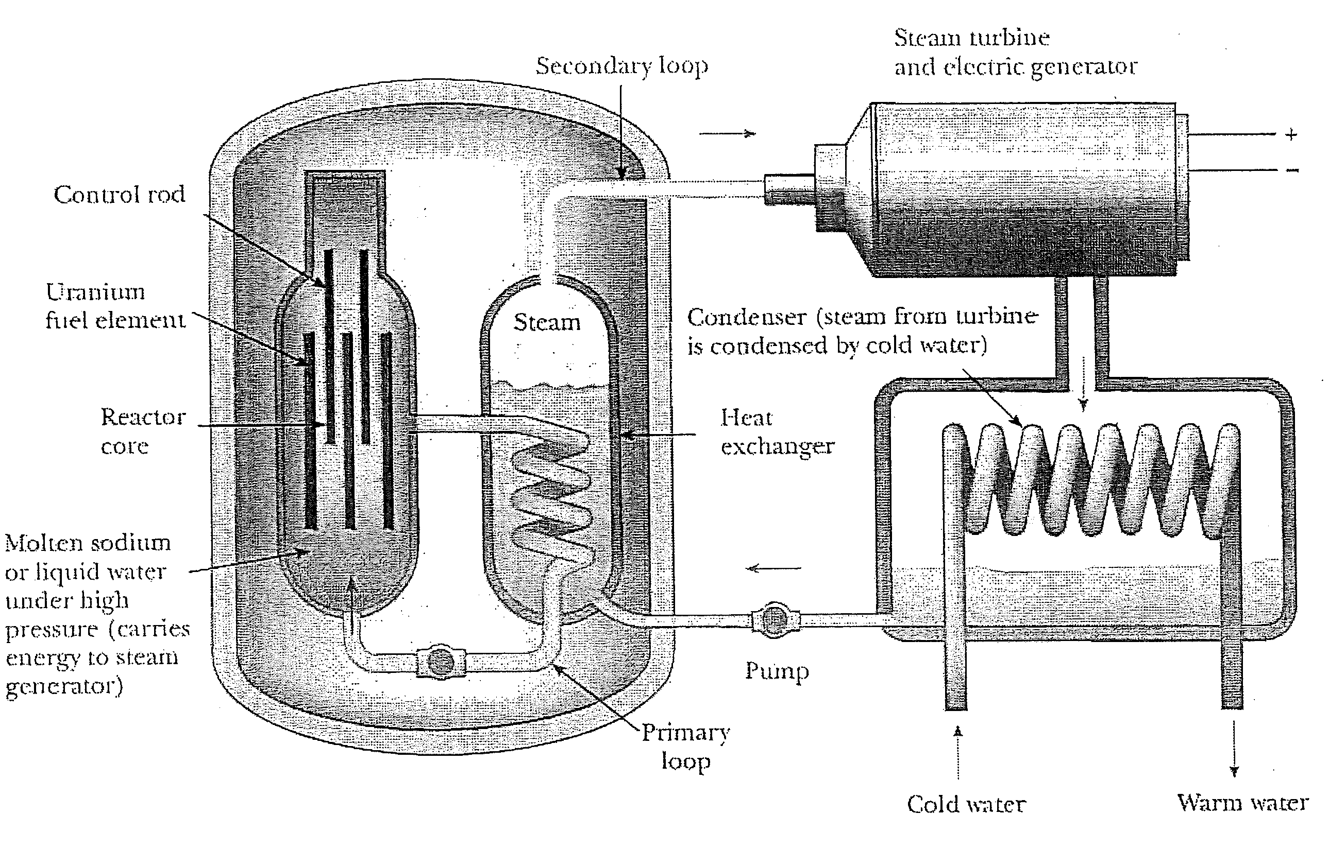
  - Explain in your own words the reaction that occurs to produce large amounts of energy in a nuclear power station. (3 marks)

  - What important role do the control rods play? (1 mark)

  - What would happen if the control rods were pulled out and then could not be pushed back in? (1 mark)

END OF TEST (OUT OF 37 MARKS)

